**Preparing the Environment for the Computer Vision Workshop**

1. Environment itself
   1. Install Anaconda for python **3,7.**  Use the link <https://www.anaconda.com/distribution/>
2. Now we need to create an Environment for tensorflow: [***using command line***]
   1. Create an environment and call it “tf”

> *conda create –n tf pip python=3.6*

* 1. Activate new environment.

> *conda activate tf*

* 1. Install Tensorflow

> pip install --ignore-installed --upgrade tensorflow==1.9

1. Install the rest packages one by one

> pip install numpy==1.16.1

> pip install opencv-python

> pip install cython

> pip install h5py

> pip install matplotlib

> pip install scikit-learn

1. Almost Done! Now Open Anaconda Navigator and Activate the new Environment

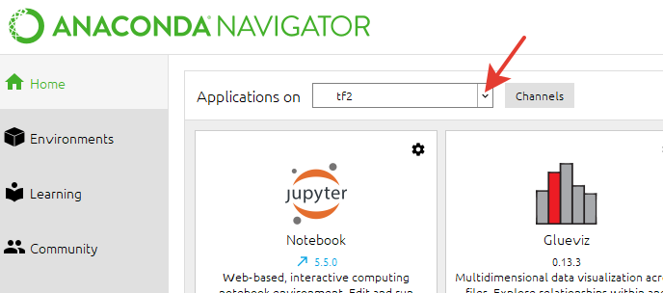

1. Install Jupyter Notebook version =5.5.0

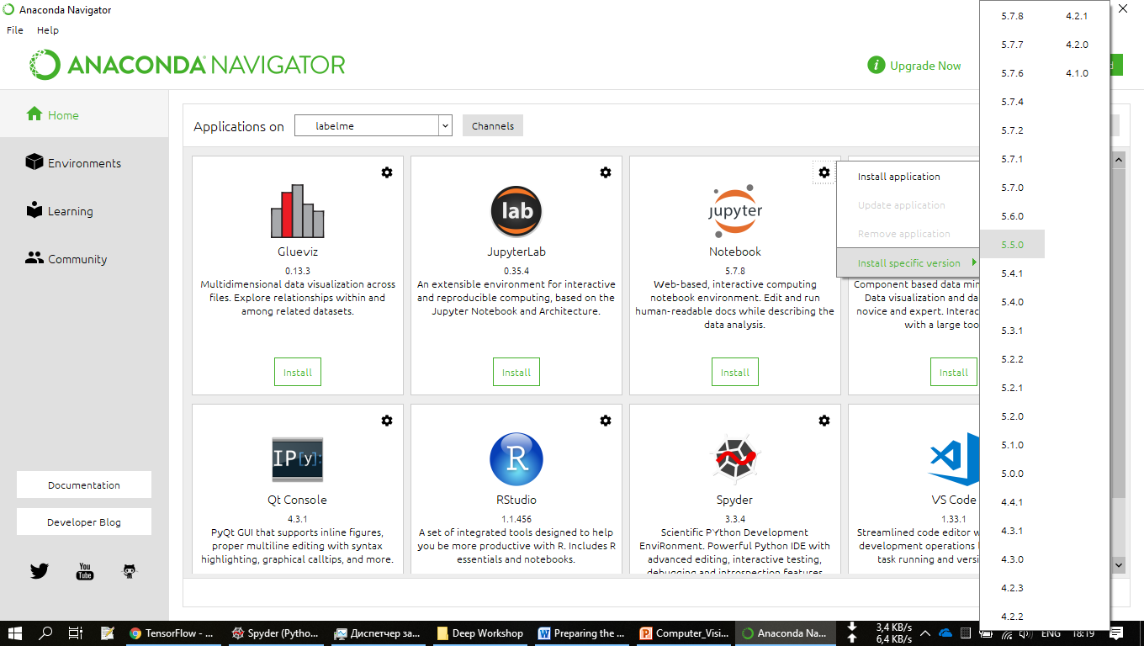

1. Launch Jupyter notebook and ensure that all libraries are installed
   1. 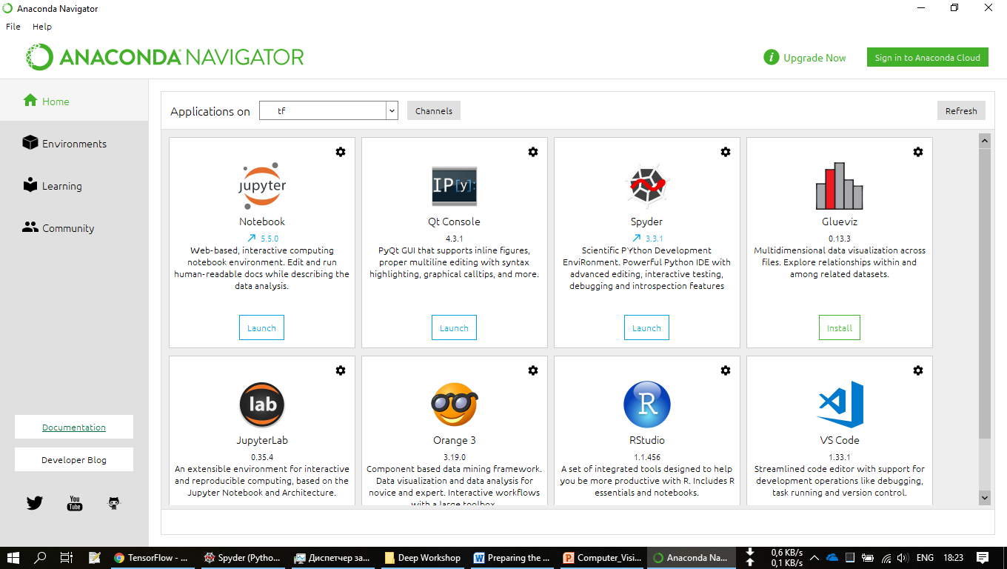
   2. Import the libraries and run the cell. There should be no errors.

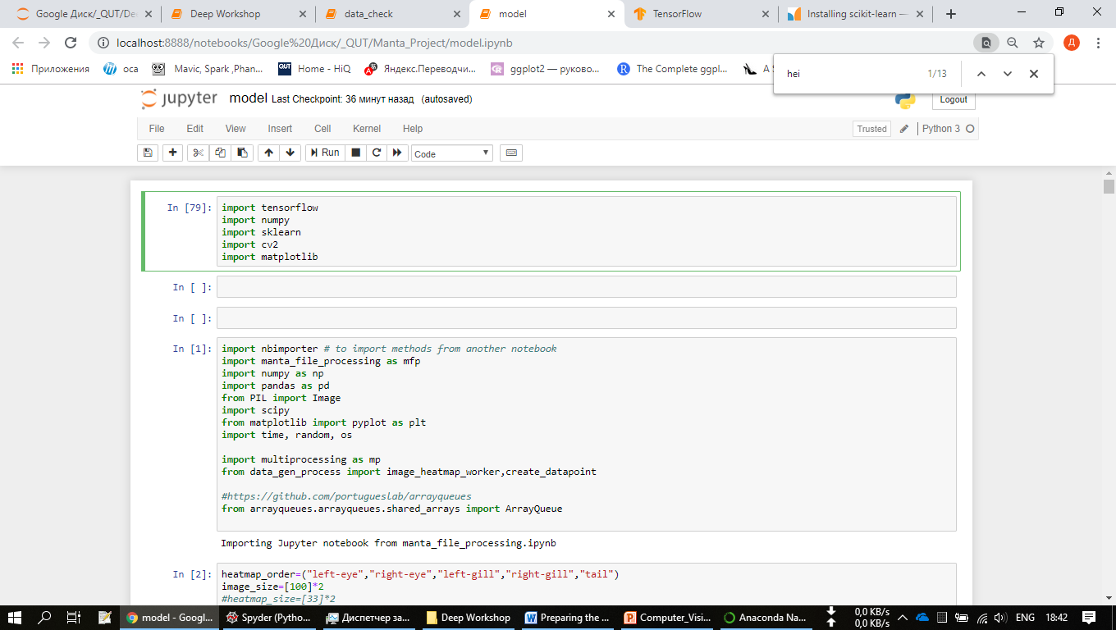

Well Done!

